# Project: Product Shop

Product Shop is a system that registers users, categories, products and orders. It is a significantly big project, and as such it will have several parts. In this exercise you will land the basics of the application, in other words - the user functionality.

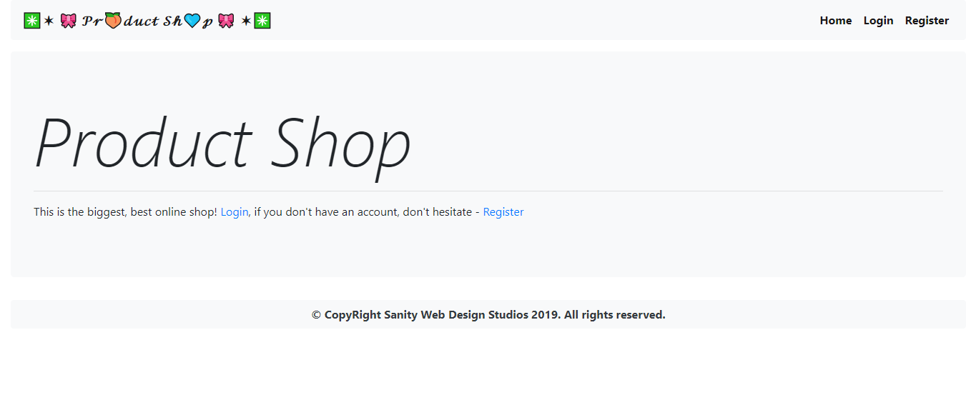

# Workshop: Part 5 – Shopping Cart

## Views

These are the additional views you must implement.

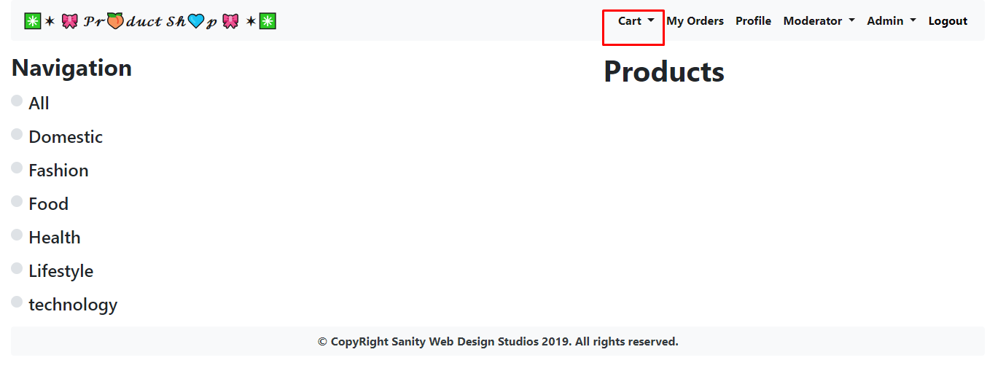

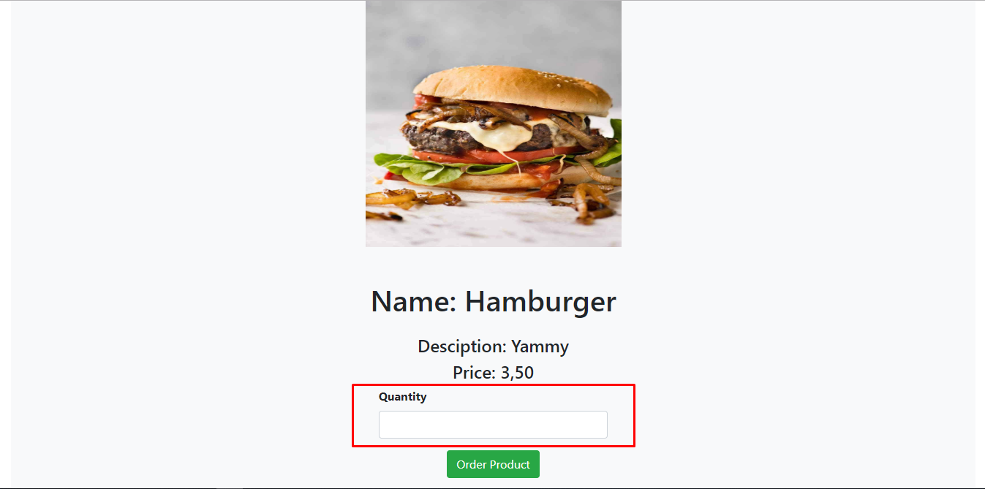

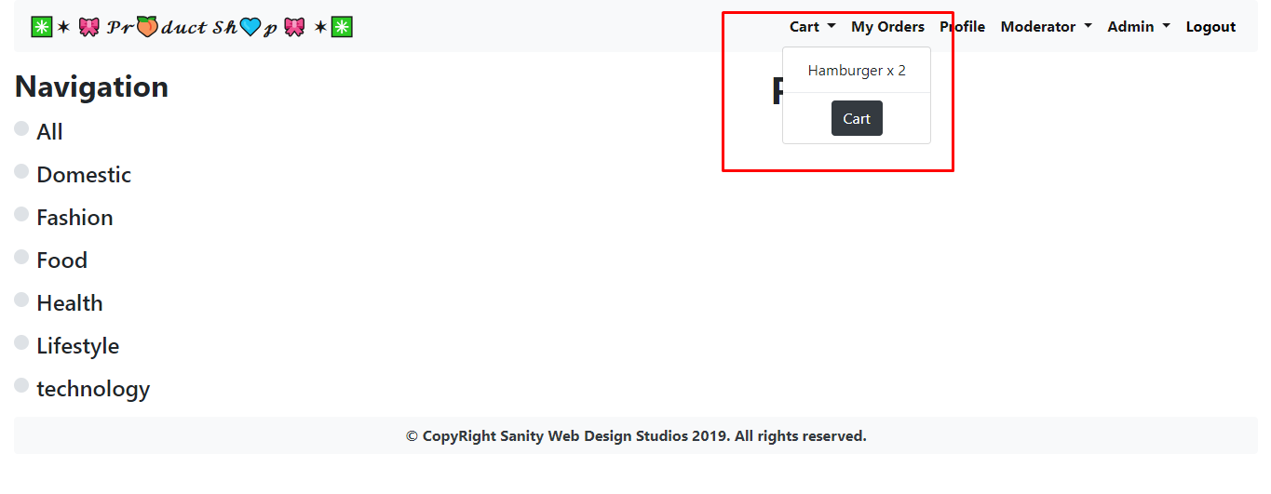

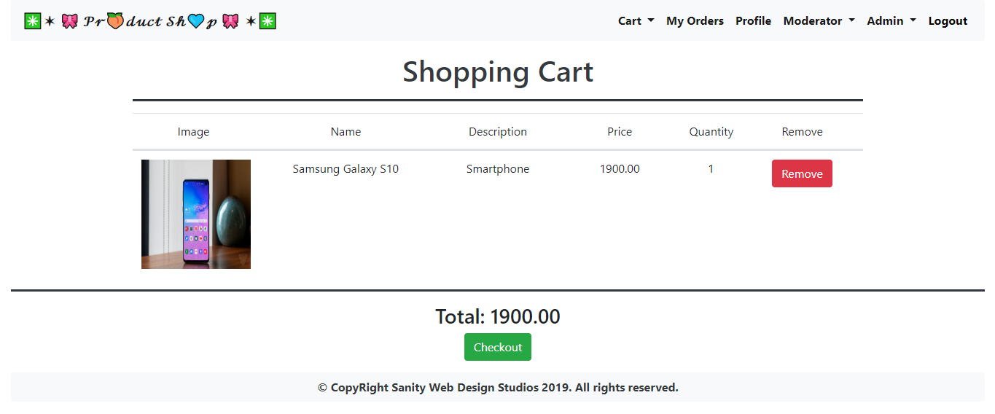

## Establish the Back-End

Create the required:

* **Entities**
* **Models**
* **Repositories**
* **Services**
* **Controllers**

## Functionality

Implement a shopping cart. You should be able to add products to cart, remove them, see details about the current condition of the cart and checkout.